**Home Automation With Voice Control and Security**

**A MINI PROJECT REPORT**

*Submitted in partial fulfillment of the*

*requirements for the award of the degree*

*of*

**BACHELOR OF TECHNOLOGY**

*in*

**ELECTRONICS & COMMUNICATION ENGINEERING**

**(ESR)**

Submitted by

**Karan Bisht (2013818)**



**DEPARTMENT OF ELECTRONICS & COMMUNICATION ENGINEERING**

**GRAPHIC ERA DEEMED TO BE UNIVERSITY, DEHRADUN – 248002 (INDIA)**

**ABSTRACT**

Home automation system achieved great popularity in the last decades and it increases the comfort and quality of life. Voice Controlled Wireless Home Automation Based on internet/ Bluetooth/ wi-fi is a project that is integrated system with mobile phone (application) to give the facility to the elderly and the disable people, so that they can easily control home utilities fully Based on their phone through voice command. The device is built in such a way that it will be easy to carry, install, configure, run and maintain for the non-technical person. Home automation involves introducing to connect the certain electrical devices that are used in a home.

**Table of content**

* **Hardware Requirements -**
* **NODE MCU Esp 8266**
* **Jumper wire**
* **One 15w bulb**
* **Relays Module**
* **Arduino UNO( for 9v power supply to NODE MCU )**
* **9v battery / Wall Adapter power supply**
* **Smartphone**
* **Software Requirements -**
* **Google Assistant Application**
* **Adafruit IO**
* **IFTTT service**
* **Arduion IDE**

**Introduction**

“Home automation” refers to the automatic and electronic control of household features, activities, and appliances. The utilities and features of our home can be easily controlled via Internet. There are three main elements of a home automation system: sensors, controllers, and actuators.

The major concept using in the Google assistant-controlled Home automation is the Internet of Things. The Internet of Things (IoT) can be connecting various types of objects like smart phones, personal computer and tablets to the internet, which brings new-fangled type of communication between things and things, and things and people.

The hardware architecture of this system consists of Node MCU and smartphone. The wireless communication between the smartphone and the Node MCU is done over the Internet. Android OS has a built-in voice recognizing feature named Google assistant which is used to develop a smartphone application which has ability to control the home appliances from user voice command. This application converts the user voice command into text, then it transmit that text message to Adafruit libraries which is connected with Node MCU through IFTTT website which is abbreviated as IF THIS THAN THAT and is a website used to create a simple chain of conditional statements called applets. One advantage of voice-controlled home automation system is that user only pronounce the appliance name in smartphone microphone and telling it to switch ON or OFF the appliances, in this way the users can control home appliance easily without any effort.

A voice recognition application provided a user-friendly interface to users and it has ability to add more home appliances into the system. This home automation system can be used in every building using electrical appliances and devices.

The main drawback of system is that it is failed to work efficiently in a noisy environment.

* **NODE MCU Esp 8266**

NodeMCU is an open-source Lua based firmware and **development board** specially targeted for IoT based Applications. It includes firmware that runs on the ESP8266 Wi-Fi SoC from Espressif Systems, and hardware which is based on the ESP-12 module.

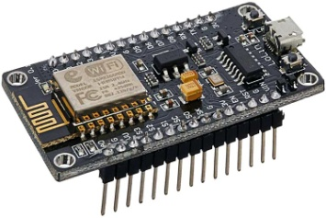

* **Jumper wire**

We are also required to use the jumping wires so that the internal connection between the different components of the Arduino Uno could be established.



* **Relays Module**

In order to control the voltage and power of the Arduino Uno, we have fitted it with the Relays module which ultimately controls and prevents the high voltage through its electromagnetic behaviour to detect the current.

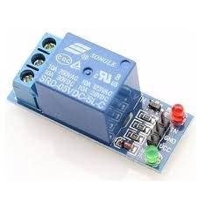

* **Google Assistant**

The Google Assistant is an Artificial Intelligence based Virtual assistant software which allows its users to control all the apps in their device. It allows the users to control and command most of the apps in their devices using voice commands.

* **Adafruit IO**

Adafruit IO is used to connect projects to Internet. It can handle and visualize multiple feed of data.

* **Arduino IDE**

The Arduino integrated development environment (IDE) is a crossplatform application (for Windows, macOS, Linux) that is written in the programming language Java. It is used to write and upload programs to Arduino compatible boards, but also, with the help of 3rd party cores, other vendor development boards.

* **IFTTT**

If This Then That, also known as IFTTT, is a free web-based service to create chains of simple conditional statements, called applets. An applet is triggered by changes that occur within other web services such as Gmail, Facebook, Telegram, Instagram,

**Circuit Digram**

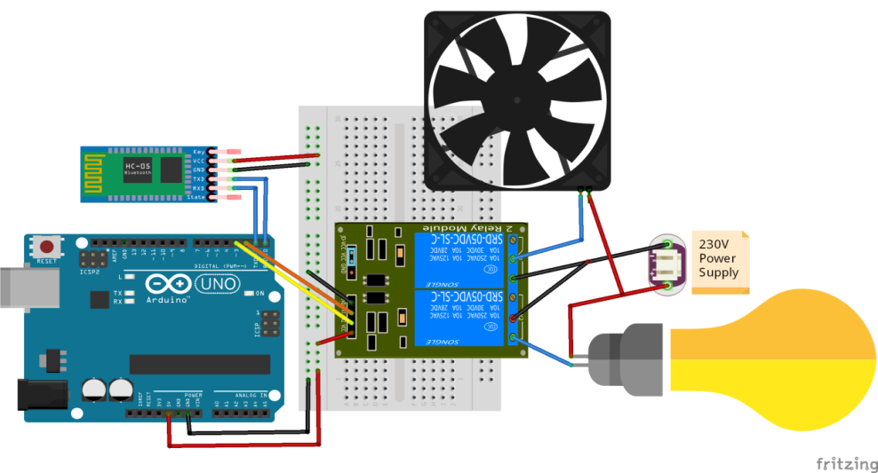

**Methodology**

There are some basic steps involving in the Methodology of the product. The first major step is setting up the Adafruit IO. Adafruit IO is a website used to create virtual switches which will be turned ON or OFF depending on the commands given to the Google assistant and the second step is connecting the ESP8266 and the last step is connecting to Google assistant through IFTTT. IFTTT is also a website used to create simple chain of conditional statements for like if else statements. By following these three steps, the implementation of the proposed system is going to be done.

**Result and Discussion**

The output for Google assistant controlled Home automation is shows the complete prototype implementation of the proposed system.

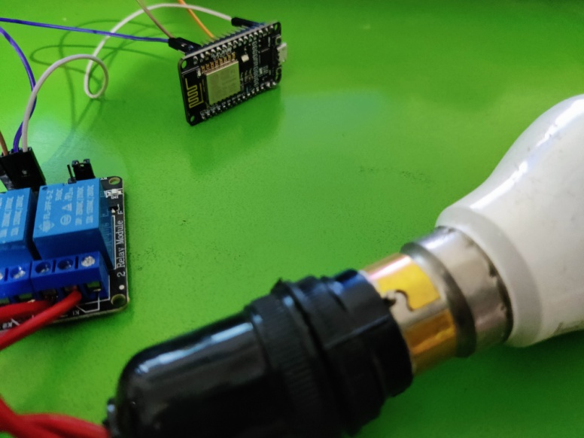

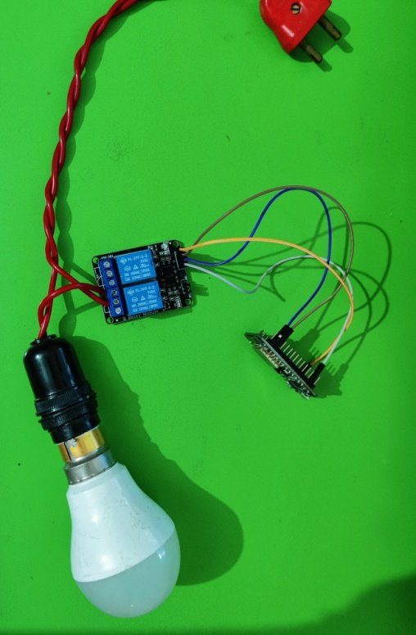

**Conclusion**

In this project, voice commands are given to the Google assistant. The voice commands for Google assistant have been added through IFTTT website and the Adafruit account is also linked to it. In this home automation, user have given commands to the Google assistant. Home appliances like Bulb, Fan and Motor etc., are controlled according to the given commands. The commands given through the Google assistant are decoded and then sent to the microcontroller and it control the relays. The device connected to the respective relay turned On or OFF as per the users request to the Google Assistant. The microcontroller used is NodeMCU (ESP8266) and the communication between the microcontroller and the application is established via Wi-Fi (Internet).